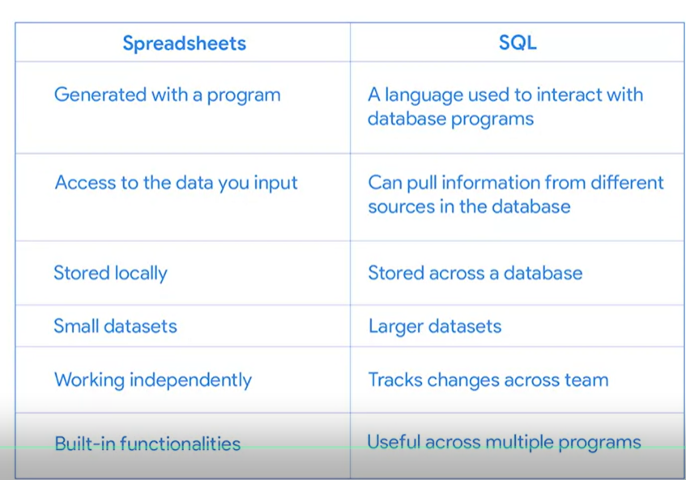
CAST() can be used to convert anything from one data type to another
CONCAT() adds strings together to create new text strings that can be used as unique keys
COLESCE() can be used to return non-null values in a list
Terms and definitions for Course 4, Module 3
CAST: A SQL function that converts data from one datatype to another
COALESCE: A SQL function that returns non-null values in a list
CONCAT: A SQL function that adds strings together to create new text strings that can be used as unique keys
DISTINCT: A keyword that is added to a SQL SELECT statement to retrieve only non-duplicate entries
Float: A number that contains a decimal
Substring: A subset of a text string
Typecasting: Converting data from one type to another

